**Fuel Cells**

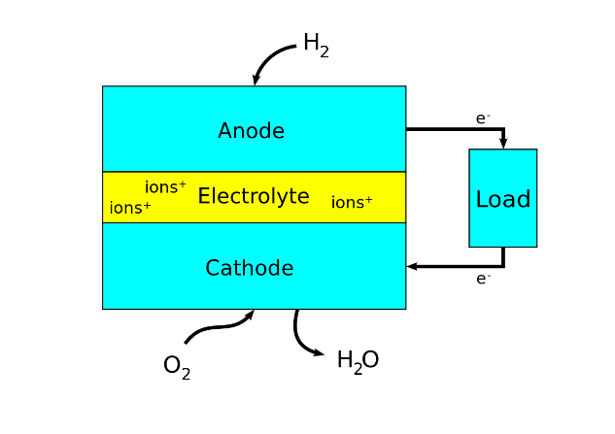A **fuel cell** is a galvanic cell that converts the chemical energy from a fuel into electricity through an electrochemical reaction of the fuel (often hydrogen) with an oxidising agent (frequently oxygen). Fuel cells are different from primary and secondary cells in requiring a continuous source of fuel and oxidant (usually oxygen from the air) to sustain the chemical reaction. In contrast, in a battery, the chemical energy comes from chemicals already present in the battery. Fuel cells can produce electricity continuously for as long as fuel and oxygen are supplied.

The most important design features in a fuel cell are:

* The electrolyte - The electrolyte substance is usually used to name the type of fuel cell
* The fuel that is used - The most common fuel is hydrogen (hydrogen is oxidised at the anode, and oxygen is reduced at the cathode)
* Two porous electrodes (usually covered in a catalyst) allow hydrogen and oxygen to come in contact with the electrolyte

**A Generalised Fuel Cell**

* External circuit

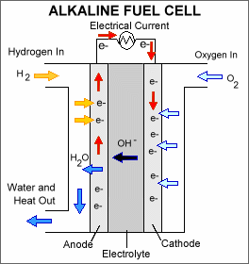**Common Fuel Cell Examples**

1. [**Alkaline Fuel Cell**](https://en.wikipedia.org/wiki/Alkaline_fuel_cell)

An alkaline fuel cell is a device that converts oxygen (from the air) and hydrogen (from a supply) into electrical energy and heat. The only by-products are water and heat – which both have commercial uses. Excluding water, an alkaline fuel cell is a zero-emission device.

In an alkaline fuel cell, the electrolyte is a porous material saturated with an aqueous alkaline solution, such as potassium hydroxide (KOH). The hydroxide ions travelling across the electrolyte allow a circuit to be made, and electrical energy can be extracted.

Anode: H2 (g)+ 2OH-(aq) 🡪 2H2O(l) + 2e- (oxidation)

Cathode: O2(g)+ 2H2O(l) + 4e- 🡪 4OH-(aq) (reduction)

Redox: 2H2(g) + O2(l) 🡪 2H2O(l)

**PROTON EXCHANGE MEMBRANE FUEL CELL**

1. 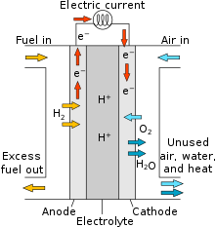[**Proton exchange membrane (polymer electrolyte membrane) fuel cells**](https://en.wikipedia.org/wiki/Proton_exchange_membrane_fuel_cell)

A fuel cell with a polymer electrolyte membrane that allows the movement of the protons produced.

Anode: H2(g) 🡪 2H+(aq) + 2e- (oxidation)

Cathode: O2(g) + 4H+(aq) + 4e- 🡪 2H2O(l) (reduction)

Redox: 2H2(g) + O2(g) 🡪 2H2O(l)

**Other fuel cell examples include:**

* [phosphoric acid fuel cell](https://en.wikipedia.org/wiki/Phosphoric-acid_fuel_cell)
* [molten carbonate fuel cell](https://en.wikipedia.org/wiki/Molten_carbonate_fuel_cell)
* [solid oxide fuel cell](https://en.wikipedia.org/wiki/Solid_oxide_fuel_cell)

For more information:

* <http://www.ausetute.com.au/fuelcell.html>
* <http://americanhistory.si.edu/fuelcells/basics.htm>

**Advantages and disadvantages of fuel cells**

